MICROCONTROLLER AND PLC
Q.1 What is the difference between Microcontroller and Microprocessor. 7.5
ANS.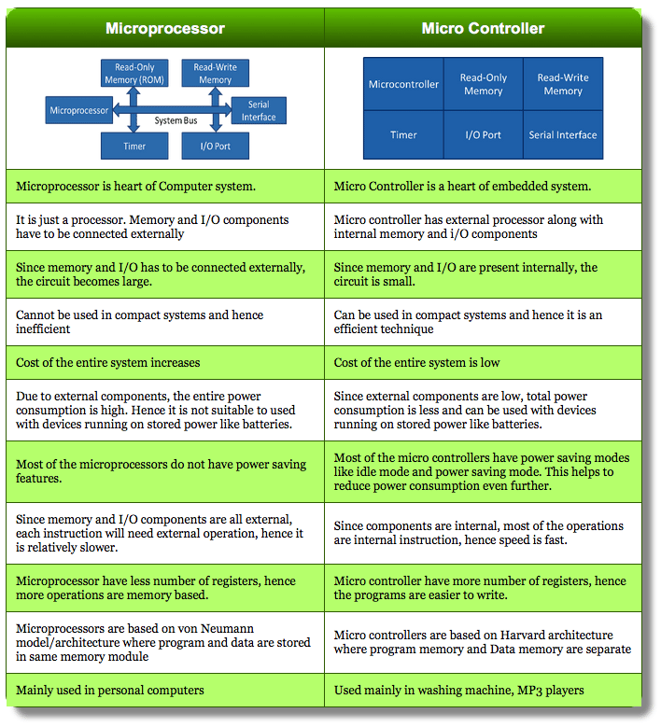

Q.2 Explain Pin Diagram of 8051 Microcontroller in detail. 7.5
ANS.8051 PIN DIAGRAM EXPLANATION
8051 Microcontroller is available in a variety of packages like 40 – pin DIP.
The following image shows the 8051 Microcontroller Pin Diagram with respect to a 40 – pin Dual In-line Package (DIP).

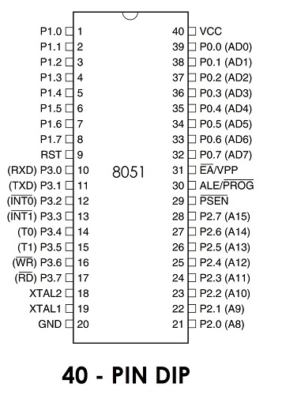

Since it is a 40 – pin DIP IC, each side contains 20 Pins.
PORT 3 Pin | Function | Description
P3.0 | RXD | Serial Input
P3.1 | TXD | Serial Output
P3.2 | INT0 | External Interrupt 0
P3.3 | INT1 | External Interrupt 1
P3.4 | T0 | Timer 0
P3.5 | T1 | Timer 1
P3.6 | WR | External Memory Write
P3.7 | RD | External Memory Read
Pin-40 : Named as Vcc is the main power source. Usually its +5V DC.
You may note some pins are designated with two signals (shown in brackets).
Pins 32-39: Known as Port 0 (P0.0 to P0.7) – In addition to serving as I/O port, lower order address and data bus signals are multiplexed with this port (to serve the purpose of external memory interfacing). This is a bi directional I/O port (the only one in 8051)
Pin-31:- EA/ External Access input is used to enable or disallow external memory interfacing.
Pin-30:- ALE means Address Latch Enable is used to demultiplex the address-data signal of port 0 (for external memory interfacing.)
Pin- 29:- PSEN or Program Store Enable is used to read signal from external program memory.
Pins- 21-28:- Known as Port 2 (P 2.0 to P 2.7) – in addition to serving as I/O port, higher order address bus signals are multiplexed with this bi directional port.
Pin 20:- Named as Vss – it represents ground connection.
Pins 18 and 19:- Used for interfacing an external crystal to provide system clock.
Pins 10 – 17:- Known as Port 3. This port also serves some other functions like interrupts, timer input, control signals for external memory interfacing RD andWR,serial communication signals RxD and TxD etc. This is a bi directional port.
Pin 9:- RESET pin is used to set the 8051 microcontroller to its initial values, while the microcontroller is working or at the initial start of application. The RESET pin must be set high for 2 machine cycles.
Pins 1 – 8:- Known as Port 1. Unlike other ports, this port does not serve any other functions except i/o task.

Q.3 Elaborate features of 8051 Microcontroller. 7.5
ANS.
Various features of 8051 microcontroller are given as follows.
- 8-bit CPU
- 16-bit Program Counter
- 8-bit Processor Status Word (PSW)
- 8-bit Stack Pointer
- Internal RAM of 128bytes
- Special Function Registers (SFRs) of 128 bytes
- 32 I/O pins arranged as four 8-bit ports (P0 - P3)
- Two 16-bit timer/counters : T0 and T1
- Two external and three internal vectored interrupts
- One full duplex serial I/O

DEVICE | ON-CHIP DATA MEMORY  (bytes) | ON-CHIP PROGRAM MEMORY  (bytes) | 16-BIT TIMER/COUNTER | NO. OF VECTORED INTERUPTS | FULL DUPLEX I/O
8031 | 128 | None | 2 | 5 | 1
8032 | 256 | None | 2 | 6 | 1
8051 | 128 | 4k ROM | 2 | 5 | 1
8052 | 256 | 8k ROM | 3 | 6 | 1
8751 | 128 | 4k EPROM | 2 | 5 | 1
8752 | 256 | 8k EPROM | 3 | 6 | 1
AT89C51 | 128 | 4k Flash Memory | 2 | 5 | 1
AT89C52 | 256 | 8k Flash memory | 3 | 6 | 1

Q.4 Describe external interfacing of memory with internal RAM and ROM.
ANS.
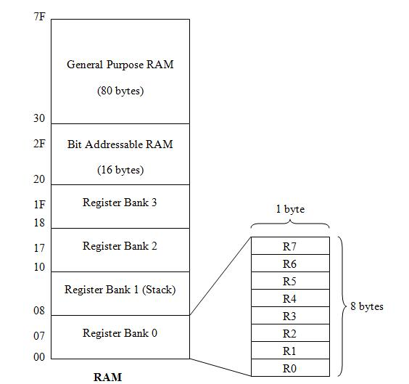

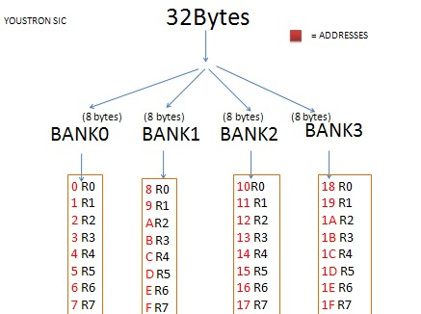

Internal RAM Structure
The lower 32 bytes are divided into 4 separate banks. Each register bank has 8 registers of one byte each. A register bank is selected depending upon two bank select bits in the PSW register. Next 16bytes are bit addressable. In total, 128bits (16X8) are available in bitaddressable area. Each bit can be accessed and modified by suitable instructions. The bit addresses are from 00H (LSB of the first byte in 20H) to 7FH (MSB of the last byte in 2FH). Remaining 80bytes of RAM are available for general purpose

Internal ROM
The 8051 has 4K (4096 locations) of on-chip ROM. This is used for storing the system program. 2¹² = 4096, therefore the internal ROM address bus is 12 bits wide and internal ROM locations go from 000H to FFFH.
Internal RAM
There are 256 bytes of internal RAM on the 8051. 2⁸ = 256, therefore the internal RAM address bus is 8 bits wide and internal RAM locations go from 00H to FFH.
The first 128 locations (00H to 7FH) of internal RAM are used by the programmer for storing data while the second 128 locations (80H to FFH) are the Special Function Registers (SFRs) which we will deal with later.

RAM Allocation in the 8051

- A total of 32 bytes from locations
00 to IF hex are set aside for reg
ister banks and the stack.

Register Banks
There are four register banks from 00H to 1FH. On power-up, registers R0 to R7 are located at 00H to 07H. However, this can be changed so that the register set points to any of the other three banks (if you change to Bank 2, for example, R0 to R7 is now located at 10H to 17H).

- A total of 16 bytes from locations
20H to 2FH are set aside for bit-
addressable read/write memory.

- A total of 80 bytes from locations
30H to 7FH are used for read and
write storage, or what is normally
called a scratch pad. These 80
locations of RAM are widely used
for the purpose of storing data and
parameters by 8051 programmers.
Bit-addressable Locations
The 8051 contains 210 bit-addressable locations of which 128 are at locations 20H to 2FH while the rest are in the SFRs. Each of the 128 bits from 20H to 2FH have a unique number (address) attached to them, as shown in the table above. The 8051 instruction set allows you to set or reset any single bit in this section of RAM.
With the general purpose RAM from 30H to 7FH and the register banks from 00H to 1FH, you may only read or write a full byte (8 bits) at these locations.
However, with bit-addressable RAM (20H to 2FH) you can read or write any single bit in this region by using the unique address for that bit.
The area of bit addressable space of 8051 is usually used to store bit variables. address range 20H to 2FH (total 128 bits) is nothing but bit addressable area as shown in fig. Each bits can be accessed from 00H to 7FH within this 128 bits from 20H to 2FH. Sometimes programming using bit addressable area saves wastage of memory. The upper 80 bytes are nothing but scratch pad area which is used for general purpose storing of data. Scratch pad area is in the address range 30H to 7FH . Scratch pad area can be used for stack memory also if default stack area is insufficient.
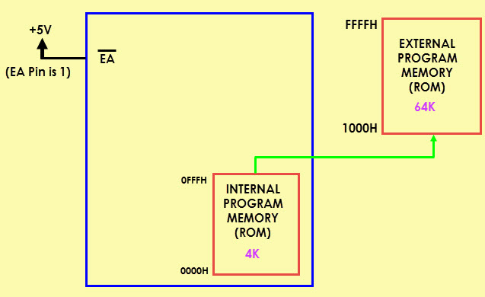

Q.5 Explain types of 8051 Microcontroller in detail. 7.5
ANS.
Types of Microcontrollers

Classification According to Number of Bits
The bits in microcontroller are 8-bits, 16-bits and 32-bits microcontroller.
In 8-bit microcontroller, the point when the internal bus is 8-bit then the ALU is performs the arithmetic and logic operations. The examples of 8-bit microcontrollers are Intel 8031/8051, PIC1x and Motorola MC68HC11 families.
The 16-bit microcontroller performs greater precision and performance as compared to 8-bit. For example 8 bit microcontrollers can only use 8 bits, resulting in a final range of 0×00 – 0xFF (0-255) for every cycle. In contrast, 16 bit microcontrollers with its 16 bit data width has a range of 0×0000 – 0xFFFF (0-65535) for every cycle. A longer timer most extreme worth can likely prove to be useful in certain applications and circuits. It can automatically operate on two 16 bit numbers. Some examples of 16-bit microcontroller are 16-bit MCUs are extended 8051XA, PIC2x, Intel 8096 and Motorola MC68HC12 families.
The 32-bit microcontroller uses the 32-bit instructions to perform the arithmetic and logic operations. These are used in automatically controlled devices including implantable medical devices, engine control systems, office machines, appliances and other types of embedded systems. Some examples are Intel/Atmel 251 family, PIC3x.

Classification According to Memory Devices
The memory devices are divided into two types, they are
- Embedded memory microcontroller
- External memory microcontroller
Embedded memory microcontroller: When an embedded system has a microcontroller unit that has all the functional blocks available on a chip is called an embedded microcontroller. For example, 8051 having program & data memory, I/O ports, serial communication, counters and timers and interrupts on the chip is an embedded microcontroller.
External Memory Microcontroller: When an embedded system has a microcontroller unit that has not all the functional blocks available on a chip is called an external memory microcontroller. For example, 8031 has no program memory on the chip is an external memory microcontroller.

Classification According to Instruction Set
CISC: CISC is a Complex Instruction Set Computer. It allows the programmer to use one instruction in place of many simpler instructions.
RISC: The RISC is stands for Reduced Instruction set Computer, this type of instruction sets reduces the design of microprocessor for industry standards. It allows each instruction to operate on any register or use any addressing mode and simultaneous access of program and data.
CISC: | Mov AX, 4 | RISC: |  | Mov AX, 0
 | Mov BX, 2 |  |  | Mov BX, 4
 | ADD BX, AX |  |  | Mov CX, 2
 |  |  | Begin | ADD AX, BX
 |  |  | Loop | Begin
Example for CISC and RISC:
From above example, RISC systems shorten execution time by reducing the clock cycles per instruction and CISC systems shorten execution time by reducing the number of instructions per program. The RISC gives a better execution than the CISC.

Q.6 Describe Architecture of 8051 Microcontroller. 7.5
ANS.
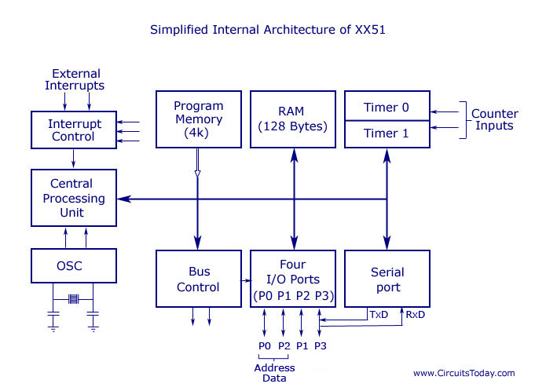
1. Oscillator and clock generator:
All operations in a microcontroller are synchronized by the help of an oscillator clock. The oscillator clock generates the clock pulses by which all internal operations are synchronized. A resonant network connected through pins XTAL1 and XTAL2 forms up an oscillator. For this purpose a quartz crystal and capacitors are employed. The crystal run at specified maximum and minimum frequencies typically at 1 MHz to 16 MHz.
2. ALU:
It is 8 bit unit. It performs arithmetic operation as addition, subtraction, multiplication, division, increment and decrement. It performs logical operations like AND, OR and EX-OR. It manipulates 8 bit and 16 bitdata. It calculates address of jump locations in relative branch instruction. It performs compare, rotate and compliment operations. It consists of Boolean processor which performs bit, set, test, clear and compliment. 8051 micro controller contains 34 general purpose registers or working registers.2 of them are called math registers A & B and 32 are bank of registers.
a. Accumulator(A-reg):
It is 8 bit register. Its address is E0H and it is bit and byte accessible. Result of arithmetic & logic operations performed by ALU is accumulated by this register. Therefore it is called accumulator register. It is used to store 8 bit data and to hold one of operand of ALU units during arithmetical and logical operations. Most of the instructions are carried out on accumulator data. It is most versatile of 2 CPU registers.
b. B-register:
It is special 8 bit math register. It is bit and byte accessible. It is used in conjunction with A register as I/P operand for ALU. It is used as general purpose register to store 8 bit data.
c. PSW:
It is 8 bit register. Its address is D0H and It is bit and byte accessible. It has 4 conditional flags or math flags which sets or resets according to condition of result. It has 3 control flags, by setting or resetting bit required operation or function can be achieved. The format of flag register is as shown below:
i. MATH FLAG:
1. Carry Flag(CY): During addition and subtraction any carry or borrow is generated then carry flag is set otherwise carry flag resets. It is used in arithmetic, logical, jump, rotate and Boolean operations.
2. Auxiliary carry flag(AC): If during addition and subtraction any carry or borrow is generated from lower 4 bit to higher 4 bit then AC sets else it resets. It is used in BCD arithmetic operations.
3. Overflow flag(OV): If in signed arithmetic operations result exceeds more than 7 bit than OV flag sets else resets.It is used in signed arithmetic operations only.
4. Parity flag(P): If in result, even no. Of ones "1" are present than it is called even parity and parity flag sets. In result odd no. Of ones "1"are present than it is called odd parity and parity flag resets.
ii. CONTROL FLAGS:
1. FO: It is user defined flag. The user defines the function of this flag. The user can set ,test n clear this flag through software.
2. RS1 and RS0: These flags are used to select bank of register by resetting those flags which are as shown in table :
3.Program counter(PC): The Program Counter (PC) is a 2-byte address which tells the 8051 where the next instruction to execute is found in memory. It is used to hold 16 bit address of internal RAM, external RAM or external ROM locations. When the 8051 is initialized PC always starts at 0000h and is incremented each time an instruction is executed. It is important to note that PC isnt always incremented by one and never decremented.
4. Data pointer register(DTPR): It is a 16 bit register used to hold address of external or internal RAM where data is stored or result is to be stored. It is used to store 16 bit data. It is divided into2- 8bit registers, DPH-data pointer higher order (83H) and DPL-data pointer lower order (82H). Each register can be used as general purpose register to store 8 bit data and can also be used as memory location. DPTR does not have single internal address. It functions as Base register in base relative addressing mode and in-direct jump.
5. Stack pointer(SP): It is 8-bit register. It is byte addressable. Its address is 81H. It is used to hold the internal RAM memory location addresses which are used as stack memory. When the data is to be placed on stack by push instruction, the content of stack pointer is incremented by 1, and when data is retrieved from stack, content of stack of stack pointer is decremented by 1.
iii. Special function Registers(SFR): The 8051 microcontroller has 11 SFR divided in 4 groups:
A. Timer/Counter register: 8051 microcontroller has 2-16 bit Timer/counter registers called Timer-reg-T0 And Timer/counter Reg-T1.Each register is 16 bit register divide into lower and higher byte register as shown below: These register are used to hold initial no. of count. All of the 4 register are byte addressable.
1. Timer control register: 8051 microcontroller has two 8-bit timer control register i.e. TMOD and TCON register. TMOD Register: it is 8-bit register. Its address is 89H. It is byte addressable. It used to select mode and control operation of time by writing control word.
2. TCON register: It is 8-bit register. Its address is 88H. It is byte addressable. Its MSB 4-bit are used to control operation of timer/ counter and LSB 4-bit are used for external interrupt control.
B. Serial data register: 8051 micro controller has 2 serial data register viz. SBUF and SCON.
1. Serial buffer register (SBUF): it is 8-bit register. It is byte addressable .Its address is 99H. It is used to hold data which is to be transferred serially.
2. Serial control register (SCON): it is 8-bit register. It is bit/byte addressable. Its address is 98H. The 8-bit loaded into this register controls the operation of serial communication.
C. Interrupt register: 8051 µC has 2 8-bit interrupt register.
1. Interrupt enable register (IE): it is 8-bit register. It is bit/byte addressable. Its address is A8H.it is used to enable and disable function of interrupt.
2. Interrupt priority register (IP): It is 8-bit register. It is bit/byte addressable. Its address is B8H. it is used to select low or high level priority of each individual interrupts.
D. Power control register (PCON): it is 8-bit register. It is byte addressable .Its address is 87H. its bits are used to control mode of power saving circuit, either idle or power down mode and also one bit is used to modify baud rate of serial communication.
Internal RAM
Internal RAM has memory 128-byte. See 8051 hardware for further internal RAM design. Internal RAM is organized into three distinct areas: 32 bytes working registers from address 00h to 1Fh 16 bytes bit addressable occupies RAM byte address 20h to 2Fh, altogether 128 addressable bits General purpose RAM from 30h to 7Fh.
Internal ROM
Data memory and program code memory both are in different physical memory but both have the same addresses. An internal ROM occupied addresses from 0000h to 0FFFh. PC addresses program codes from 0000h to 0FFFh. Program addresses higher than 0FFFh that exceed the internal ROM capacity will cause 8051 architecture to fetch codes bytes from external program memory.

Q.7 Describe PSW and also functions of RS1 and RS1 7.5
ANS
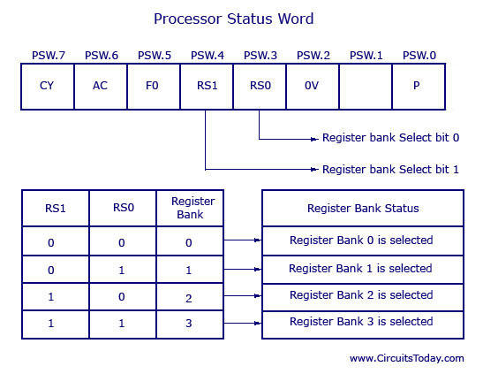
The program status word (PSW) register is an 8-bit register. It is also referred to as the flag register. Although the PSW register is 8 bits wide, only 6 bits of it are used by the 8051. The two unused bits are user-definable flags. Four of the flags are called conditional flags, meaning that they indicate some conditions that result after an instruction is executed. These four are CY (carry), AC (auxiliary carry), P (parity), and OV (overflow).
As seen from Figure 2-4, the bits PSW.3 and PSW.4 are designated as RSO and RSI, respectively, and are used to change the bank registers. They are explained in the next section. The PSW.5 and PSW.l bits are general-purpose status flag bits and can be used by the programmer for any purpose. In other words, they are user definable. See Figure 2-4 for the bits of the PSW register.
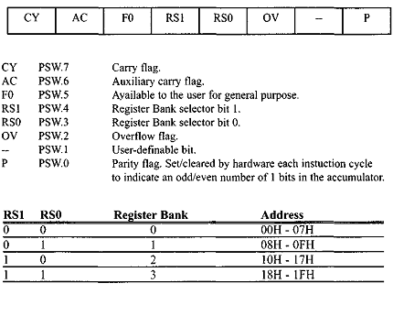

Q.8 Explain Interrupts in 8051 Microcontroller. 7.5
ANS.

What is an Interrupt?
Interrupt is a signal which has highest priority from hardware or software which processor should process its signal immediately.

Types of Interrupts:
Although interrupts have highest priority than other signals, there are many type of interrupts but basic type of interrupts are
- Hardware Interrupts: If the signal for the processor is from external device or hardware is called hardware interrupts. Example: from keyboard we will press the key to do some action this pressing of key in keyboard will generate a signal which is given to the processor to do action, such interrupts are called hardware interrupts. Hardware interrupts can be classified into two types they are
  - Maskable Interrupt: The hardware interrupts which can be delayed when a much highest priority interrupt has occurred to the processor.
  - Non Maskable Interrupt: The hardware which cannot be delayed and should process by the processor immediately.
- Software Interrupts: Software interrupt can also divided in to two types. They are
  - Normal Interrupts: the interrupts which are caused by the software instructions are called software instructions.
  - Exception: unplanned interrupts while executing a program is called Exception. For example: while executing a program if we got a value which should be divided by zero is called a exception.
Classification of Interrupts According to Periodicity of Occurrence:
- Periodic Interrupt: If the interrupts occurred at fixed interval in timeline then that interrupts are called periodic interrupts
- Aperiodic Interrupt: If the occurrence of interrupt cannot be predicted then that interrupt is called aperiodic interrupt.

Types of Interrupts in 8051 Microcontroller
The 8051 microcontroller can recognize five different events that cause the main program to interrupt from the normal execution. These five sources of interrupts in 8051are:
- Timer 0 overflow interrupt- TF0
- Timer 1 overflow interrupt- TF1
- External hardware interrupt- INT0
- External hardware interrupt- INT1
- Serial communication interrupt- RI/TI
The Timer and Serial interrupts are internally generated by the microcontroller, whereas the external interrupts are generated by additional interfacing devices or switches that are externally connected to the microcontroller. These external interrupts can be edge triggered or level triggered. When an interrupt occurs, the microcontroller executes the interrupt service routine so that memory location corresponds to the interrupt that enables it. The Interrupt corresponding to the memory location is given in the interrupt vector table below.
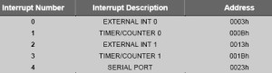
Interrupt vector Table

